ENGINEERING PUBLICATION
MOTION CONTROL DIVISION

PRODUCT: JUSP-NS600 & index works
SUBJECT: Self-Teach Indexer exercises
CATEGORY: Application Note
ENGINEER: Paul Zajac DISTRIBUTION: MCD

Summary: The following Indexer example exercises should be entered using IndexWorks. Answers to the exercises are also provided.

Exercise #1a
Enter and download the following program into the Indexer using IndexWorks. Test the program after downloading.

It is recommended to reset the Indexer to all factory defaults before starting a new application. This can be done in IndexWorks by selecting Tools…Reset to Factory Defaults…All Defaults.

Application:
Mechanical System: Ballscrew Actuator: Lead=20mm
10:1 gearbox

Move Profile: Positioning Resolution=0.001mm
Typical Index: 100mm in 1.6 sec (triangular move profile)
Turn on output /POUT0 at the start of the index (as shown below).
/POUT0
speed
time
v
100 mm

Exercise #1b
Add a second index of 400 mm. /POUT1 should turn on at the end of the first index and turn off at the start of the second index (as shown below).
speed
time
v
3 sec
100 mm
400 mm
/POUT0
/POUT1

Exercise #1c
Add in a 75 mm registration distance and a 100 mm/sec registration speed to the second index.

Exercise #1d
Add output /POUT2 as shown below.
time
v
3 sec
4 sec
speed
100 mm
400 mm
/POUT0
/POUT1
/POUT2

Exercise #1e:
Add a homing routine – actuator should start homing at 50 mm/sec in the forward direction, decelerate to a 25 mm/sec approach speed once the home sensor is reached, stop at the C-phase pulse, and then creep 5 mm from the C-phase pulse in the opposite direction at 10 mm/sec. Also, add a final index to return the actuator to position 0 at the maximum speed of the motor (5000rpm).

Exercise #2a:
Start a New Project. Enter and download the following program into the Indexer using IndexWorks. Test the program after downloading.

It is recommended to reset the Indexer to all factory defaults before starting a new application. This can be done in IndexWorks by selecting Tools…Reset to Factory Defaults…All Defaults.

Application:
Mechanical System: Rotary table with 6 positions (0º, 60 º, 120 º, 180 º, 240 º, and 300 º)
1 to1 gearbox.
Move Profile: Positioning Resolution: 0.01 º
60 º in 0.10 seconds (triangular move profile)
Moves should take the shortest path of travel.
Set up a program table such that program step 0 is 0 º, program step 1 is 60 º, program step 2 is 120 º …
Output /POUT0 should turn on when within 20 º of each position. Output /POUT4 should turn on when within 10 º of each position. All outputs should turn off at the start of the next move.

Exercise #2b:
Outputs /POUT2 and /POUT3 should turn on whenever the rotary table is between 90 º and 180 º.

Solution to Exercise #1a:

First reset the Indexer to all factory defaults.

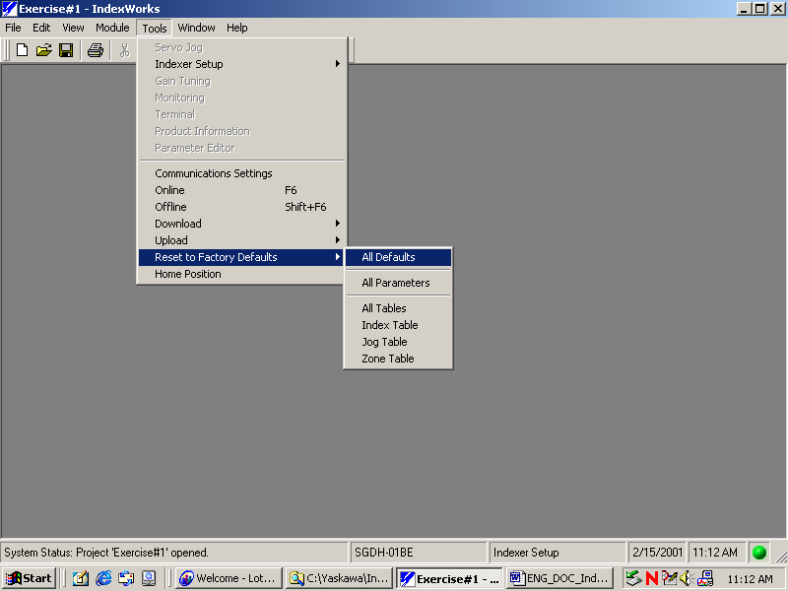

Calculate the desired speed, acceleration, and deceleration for a triangular move profile.

$$\begin{aligned}\text{Speed}=\frac{2\left(\text{100}\text{mm}\right)}{1\text{.}6\text{sec}}=\text{125}\text{mm}\text{/sec} \\ \text{Accel}=\text{Decel}=\frac{\text{125}\text{mm}\text{/sec}}{0\text{.}8\text{sec}}=\text{156}\text{.}\text{25}\text{mm}\text{/sec/sec}\end{aligned}$$

Edit the Mechanical System window by selecting the Indexer Setup Module and then Tools…Indexer Setup…Mechanical System. Make sure to select the correct encoder resolution or select Get Encoder Count while online. Select Apply or OK to accept the changes.

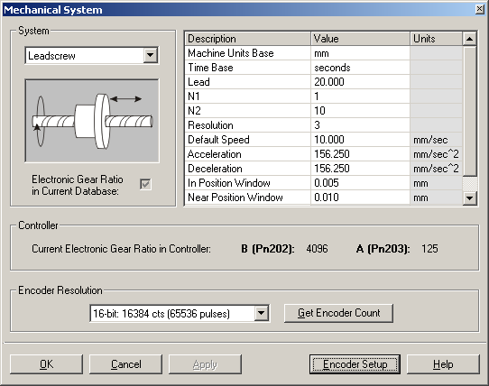

Enter the index into the Index Table by selecting the Indexer Setup Module and then Tools…Indexer Setup…Index. Select Apply or OK to accept the changes. Select Tools…Download…Download All or Download New to send changes to the Indexer.

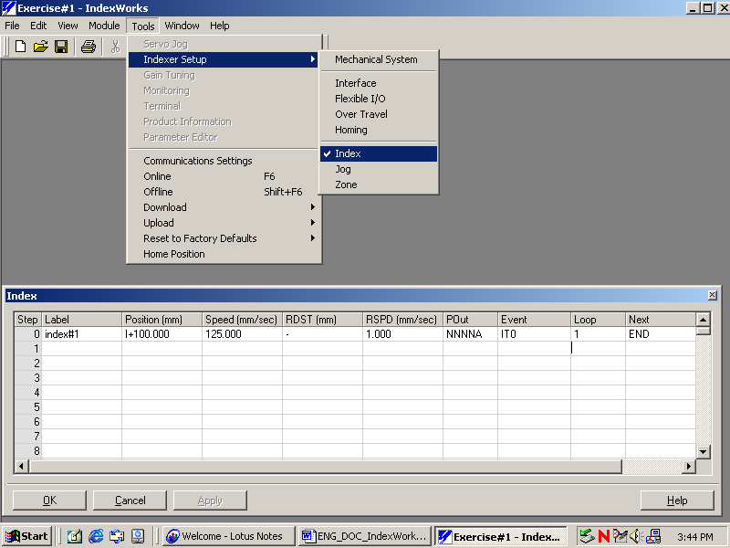

Solution to Exercise #1b:

Enter the new changes to the Index Table. Select Apply or OK and Download the new changes to the Indexer.

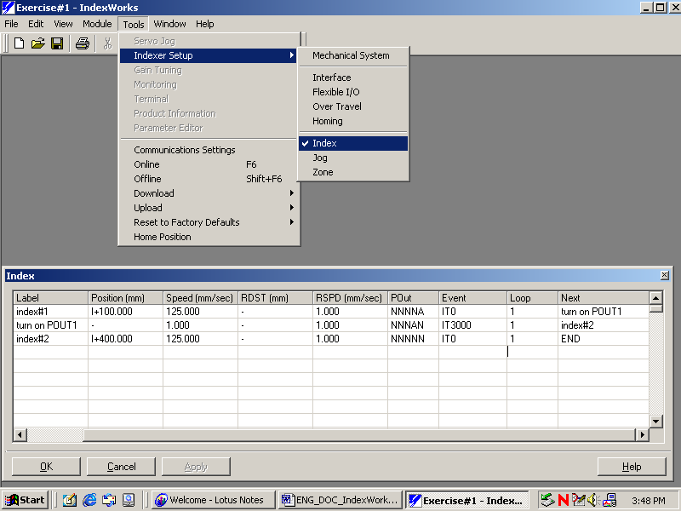

Solution to Exercise #1c:

Add the registration distance and speed to index#2. Select Apply or OK and Download the new changes to the Indexer.

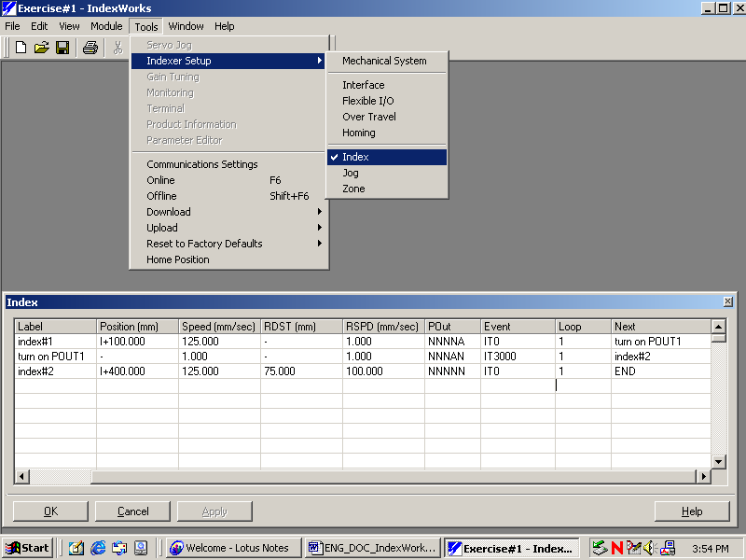

Solution to Exercise #1d:

Enter the new changes to the Index Table. Select Apply or OK and Download the new changes to the Indexer.

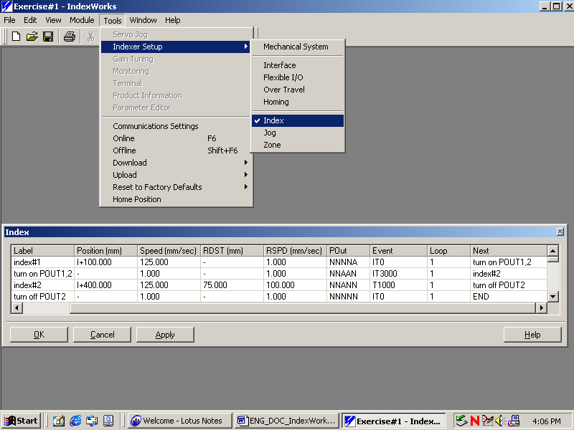

Solution to Exercise #1e:

Enter the Homing parameters into the Homing window. Select Apply or OK to accept the changes.

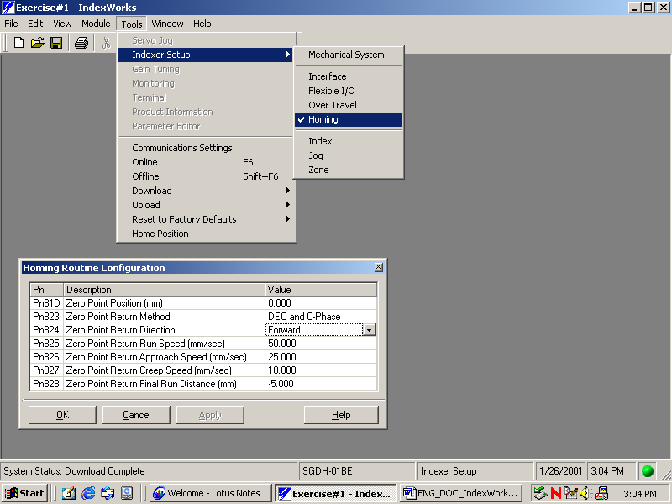

Convert 5000 rpm into mm/sec:

$$\begin{aligned}\text{rpm}×\frac{\text{encoder}\text{.}\text{pulses}}{\text{revolution}}×\frac{\text{Pn}\text{203}\text{ElectronicGearRatioA}(\text{ref}\text{.}\text{units})}{\text{Pn}\text{202}\text{ElectronicGearRatioB}(\text{encoder}\text{.}\text{pulses})}×\frac{\text{min}}{\text{60}\text{sec}}×\frac{1x{\text{10}}^{−\text{Re}\text{solution}}\text{mm}}{\text{ref}\text{.}\text{units}}=\text{mm}\text{/sec} \\ \text{5000}\text{rpm}×\frac{\text{65},\text{536}\text{encoder}\text{.}\text{pulses}}{\text{rev}\text{.}}×\frac{\text{125}\text{ref}\text{.}\text{units}}{\text{4096}\text{encoder}\text{.}\text{pulses}}×\frac{\text{min}}{\text{60}\text{sec}}×\frac{0\text{.}\text{001}\text{mm}}{\text{ref}\text{.}\text{units}}=\text{166}\text{.}\text{667}\text{mm}\text{/sec}\end{aligned}$$
Note: Values used in the equation may be different if not using a 16-bit encoder. The answer should be the same.
The answer should match the answer from the following calculation:

$$\text{5000}\text{rpm}×\frac{\text{20}\text{mm}}{{\text{rev}}_{\text{load}\text{.}\text{shaft}}}×\frac{{\text{rev}}_{\text{laod}\text{.}\text{shaft}}}{\text{10}{\text{rev}}_{\text{motor}\text{.}\text{shaft}}}×\frac{\text{min}}{\text{60}\text{sec}}=\text{166}\text{.}\text{667}\text{mm}\text{/sec}$$

Enter the return speed in the Index Table. Select Apply or Ok and Download the new changes to the Indexer.

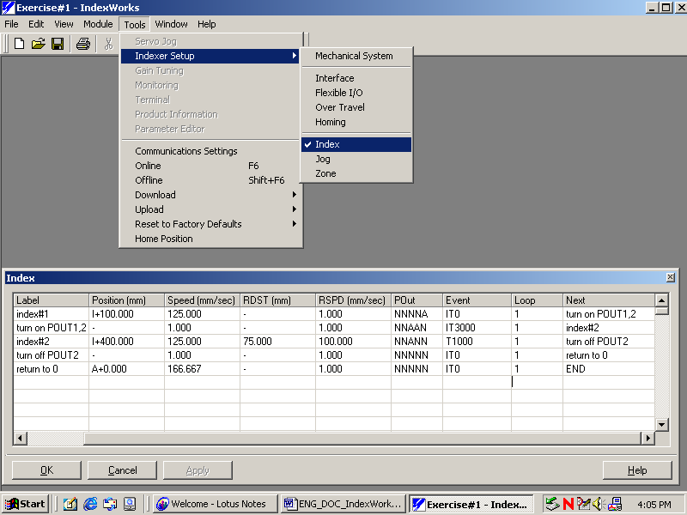

Solution to Exercise #2a:

First reset the Indexer to all factory defaults.

Calculate the desired speed, acceleration, and deceleration.

$$\begin{aligned}\text{Speed}=\frac{2\left(\text{60}\text{deg}\right)}{0\text{.}1\text{sec}}=1,\text{200}\text{deg/sec} \\ \text{Accel}=\text{Decel}=\frac{1,\text{200}\text{deg/sec}}{0\text{.}\text{05}\text{sec}}=\text{24},\text{000}\text{deg/sec/sec}\end{aligned}$$

Edit the Mechanical System window by selecting the Indexer Setup Module and then Tools…Indexer Setup…Mechanical System. Make sure to select the correct encoder resolution or select Get Encoder Count while online. Select Apply or OK to accept the changes.

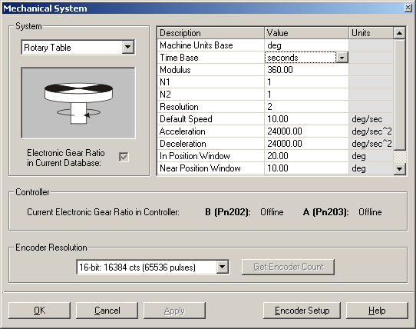
Edit the Over Travel window by selecting Tools…Indexer Setup…Over Travel. This window is used to select the type of motion, whether it be linear or rotary (Motion Method) and to set position limits (linear-software position limits, linear – modulus). Select Apply or OK to accept the changes.

IndexWorks 1.3.5 and above will automatically select Rotary(Shortest Path) and set the position limits according to the Modulus entered in the Mechanical System window when a rotary mechanical system is selected. Note that there are also Motion Method options for Rotary (Forward) and Rotary (Reverse).

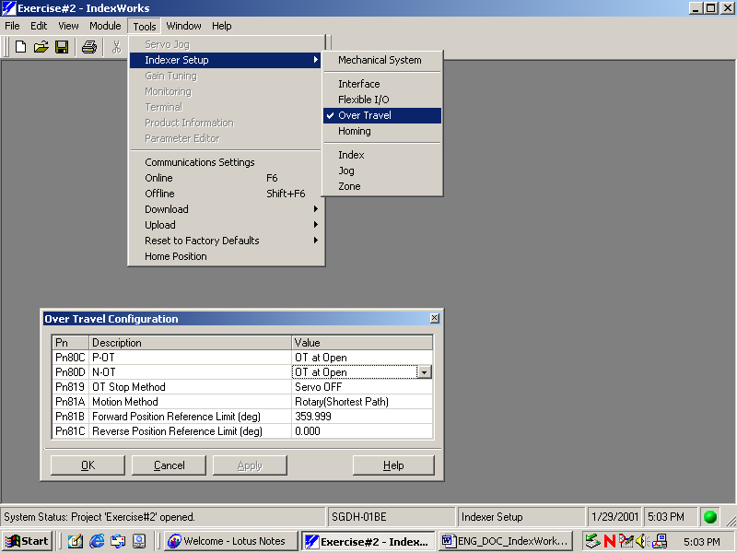

Enter the rotary positions and output conditions into the Index Table by selecting the Indexer Setup Module and then Tools…Indexer Setup…Index. Select Apply or OK to accept the changes. Select Tools…Download…Download All or Download New to send changes to the Indexer.

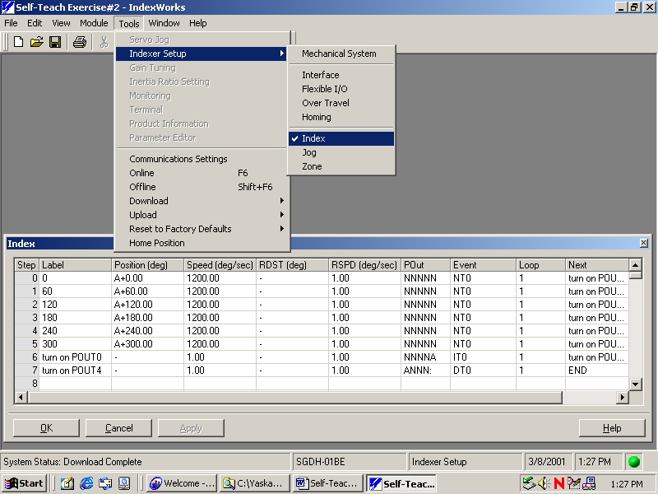

Solution to Exercise #2b:

Edit the Index Table POUT column to accommodate for the zone conditions. Select Apply or OK to accept the changes.

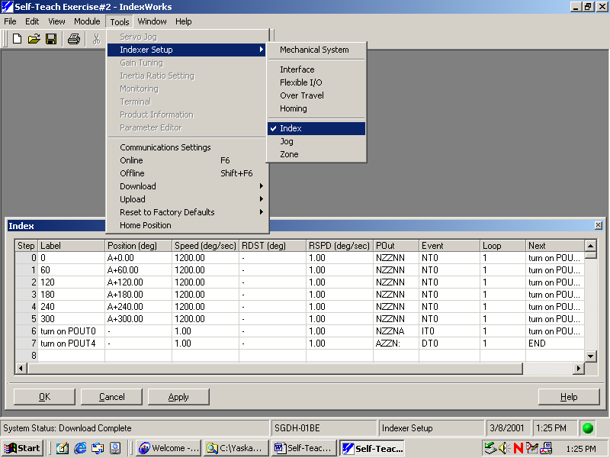

Edi the Zone Table by selecting the Indexer Setup Module and then Tools…Indexer Setup…Zone. Enter the zone boundary limits to the appropriate zone number. Select Apply or OK to accept the changes. Select Tools…Download…Download All or Download New to send changes to the Indexer.

