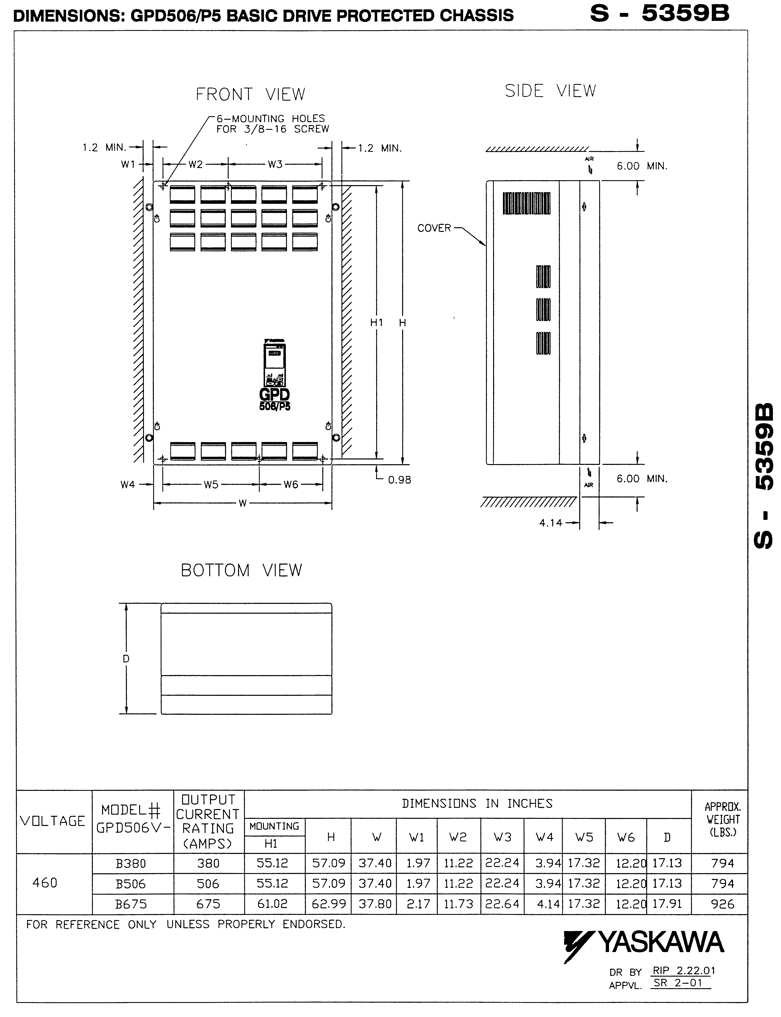
Document: S-5359B

;
Contractor
Address
Job Name:
Contractor:

;
Contractor
Address

