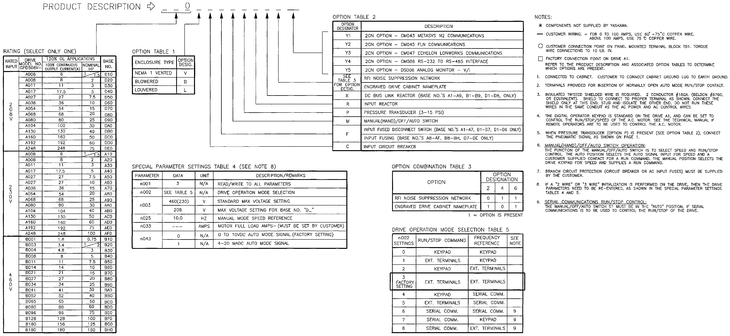

Document: C23-OO
Sheet 2 of 2

;
Contractor
Address
Job Name:
Contractor:

;
Contractor
Address

