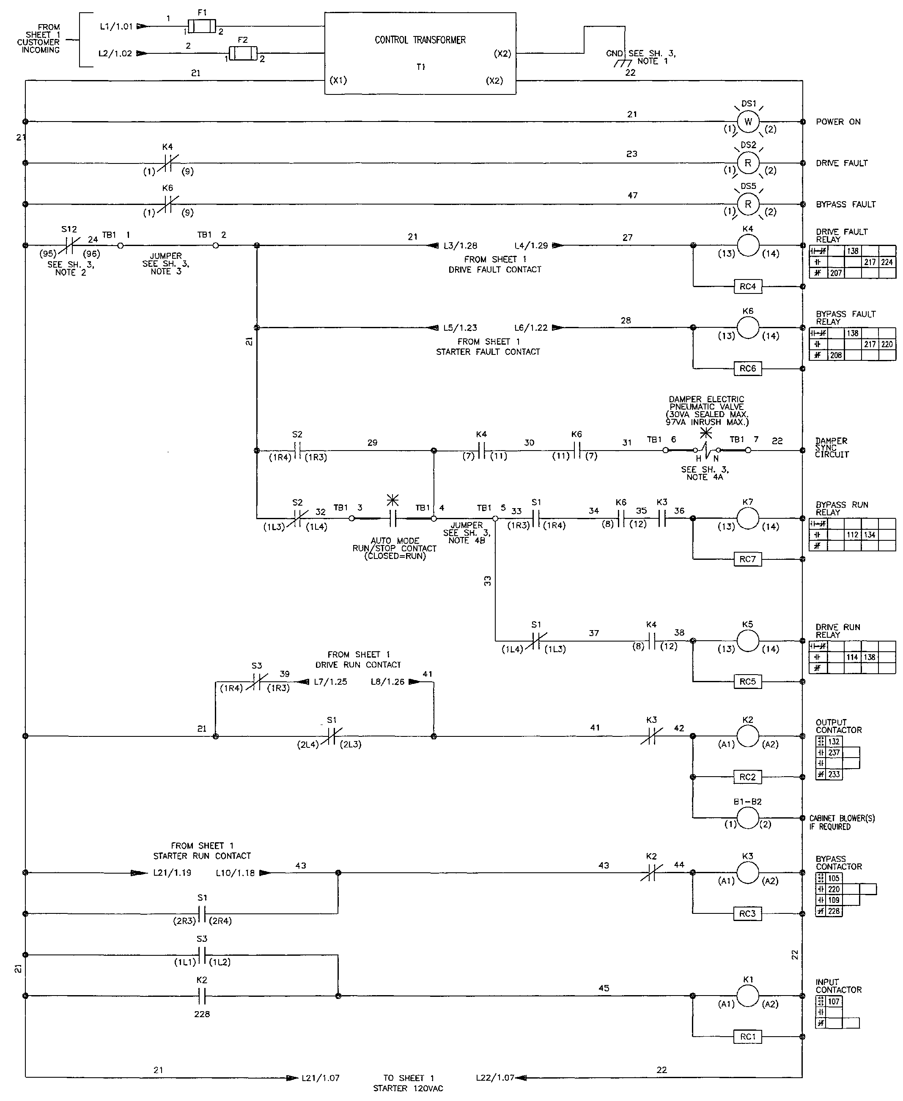
Document: C21-Soft Start Sheet 2 of 3

;
Contractor
Address
Job Name:
Contractor:

;
Contractor
Address
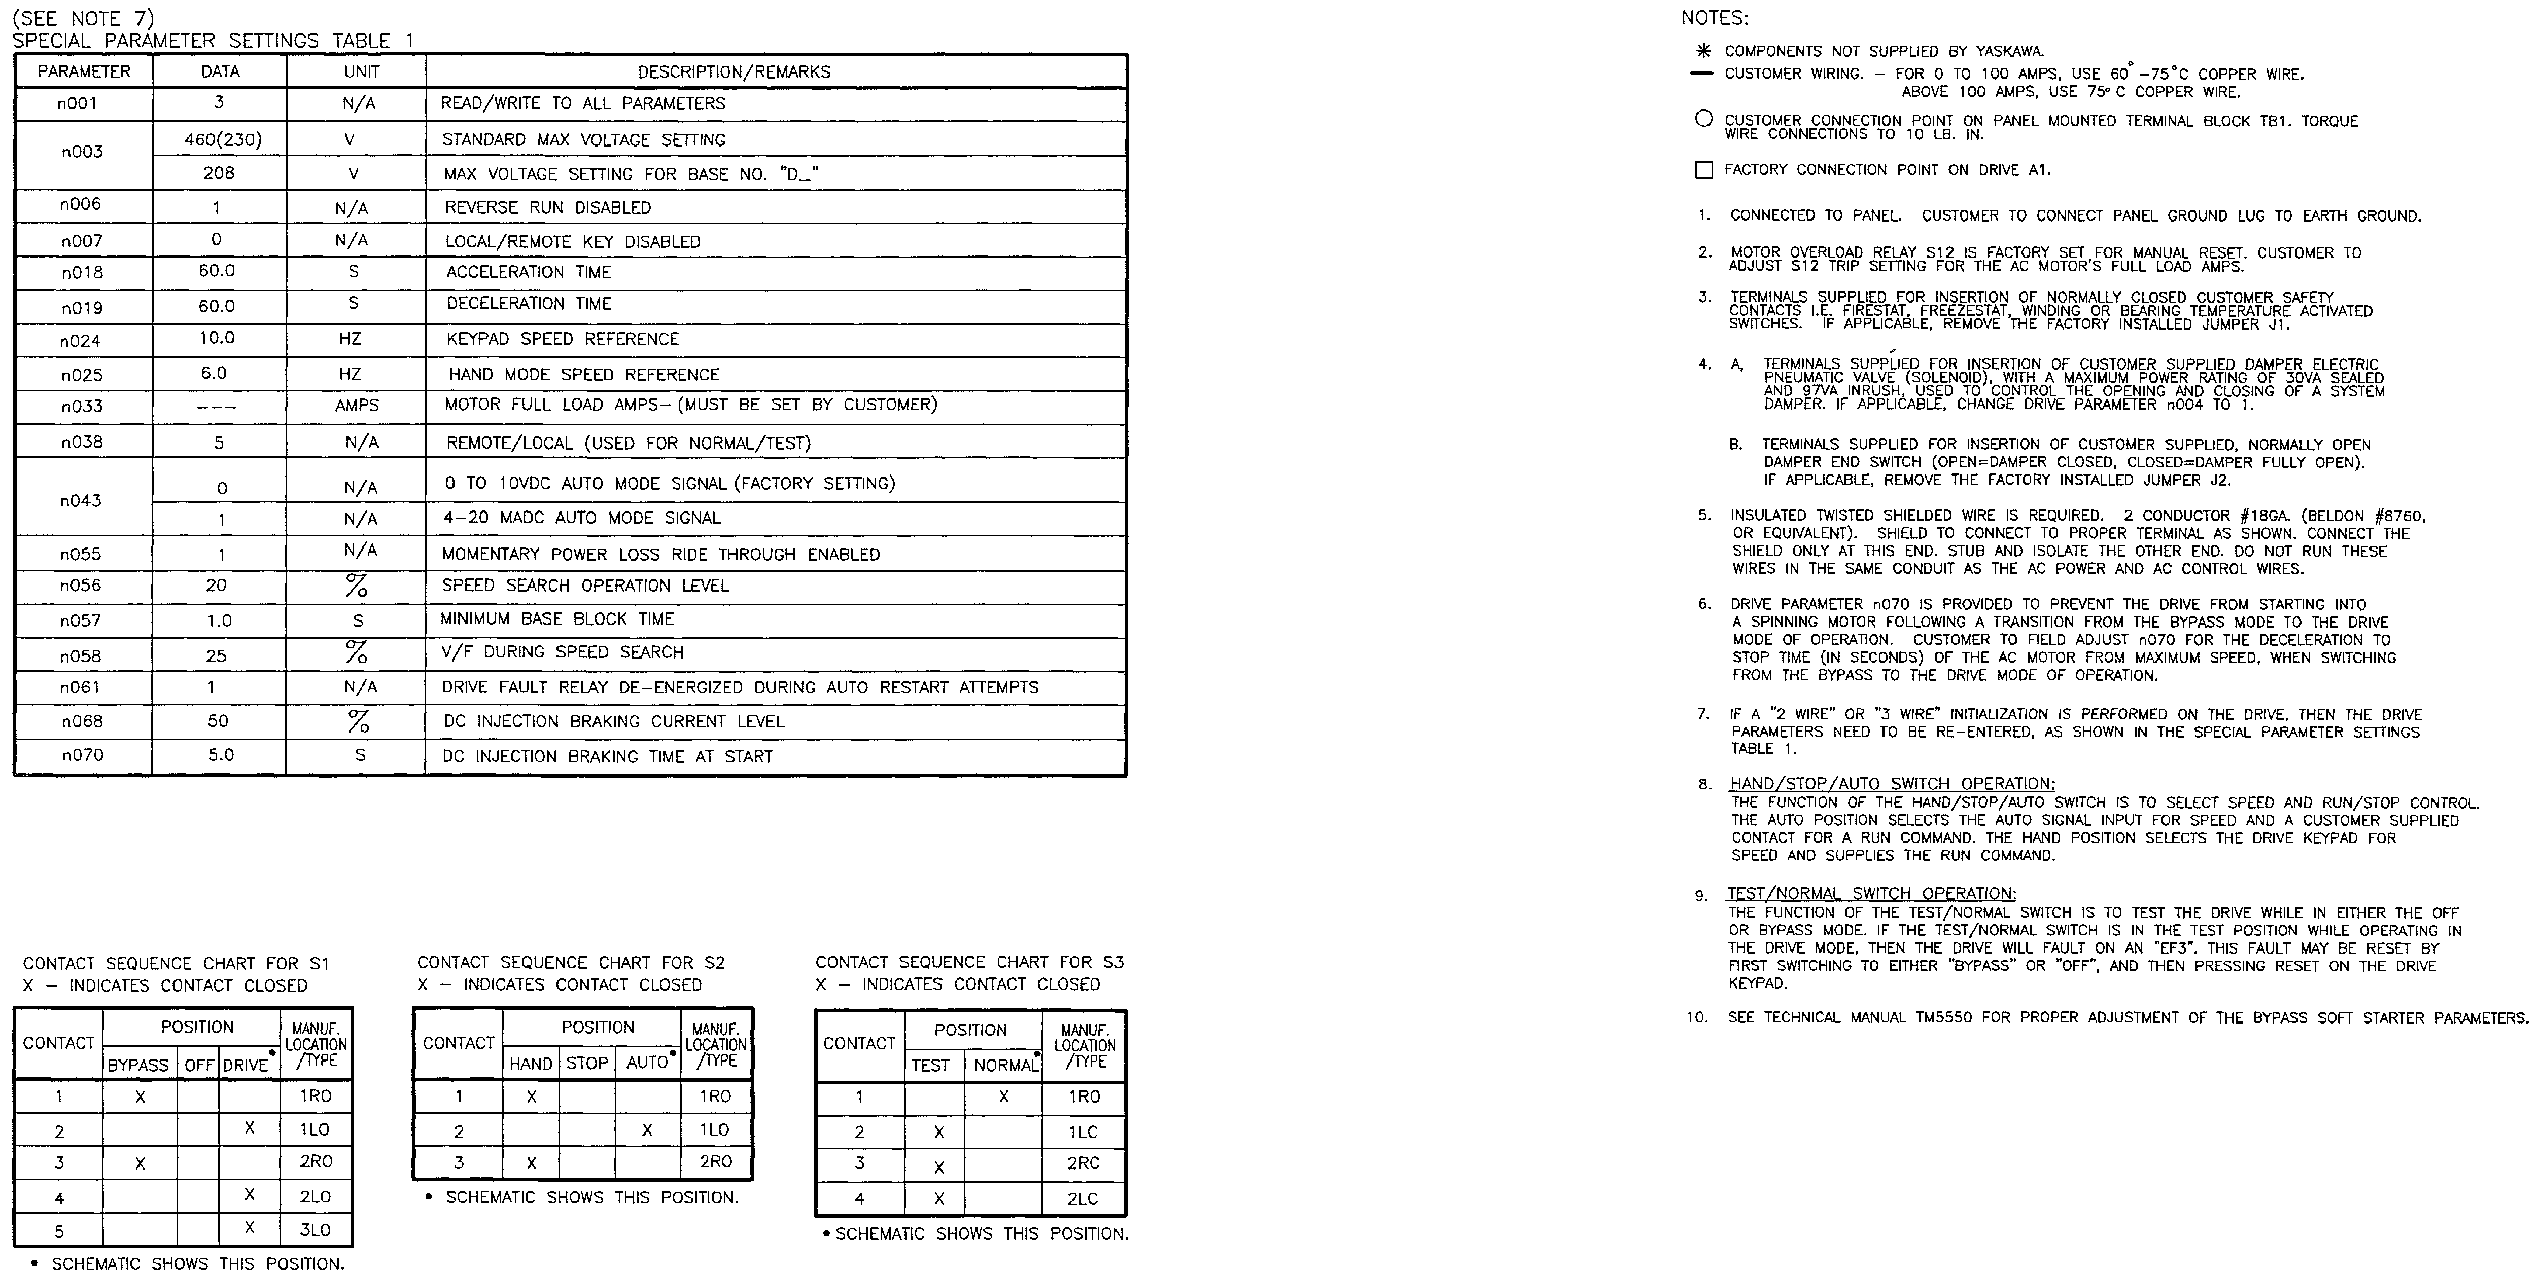
Document: C21-Soft Start Sheet 3 of 3

;
Contractor
Address
Job Name:
Contractor:

;
Contractor
Address

