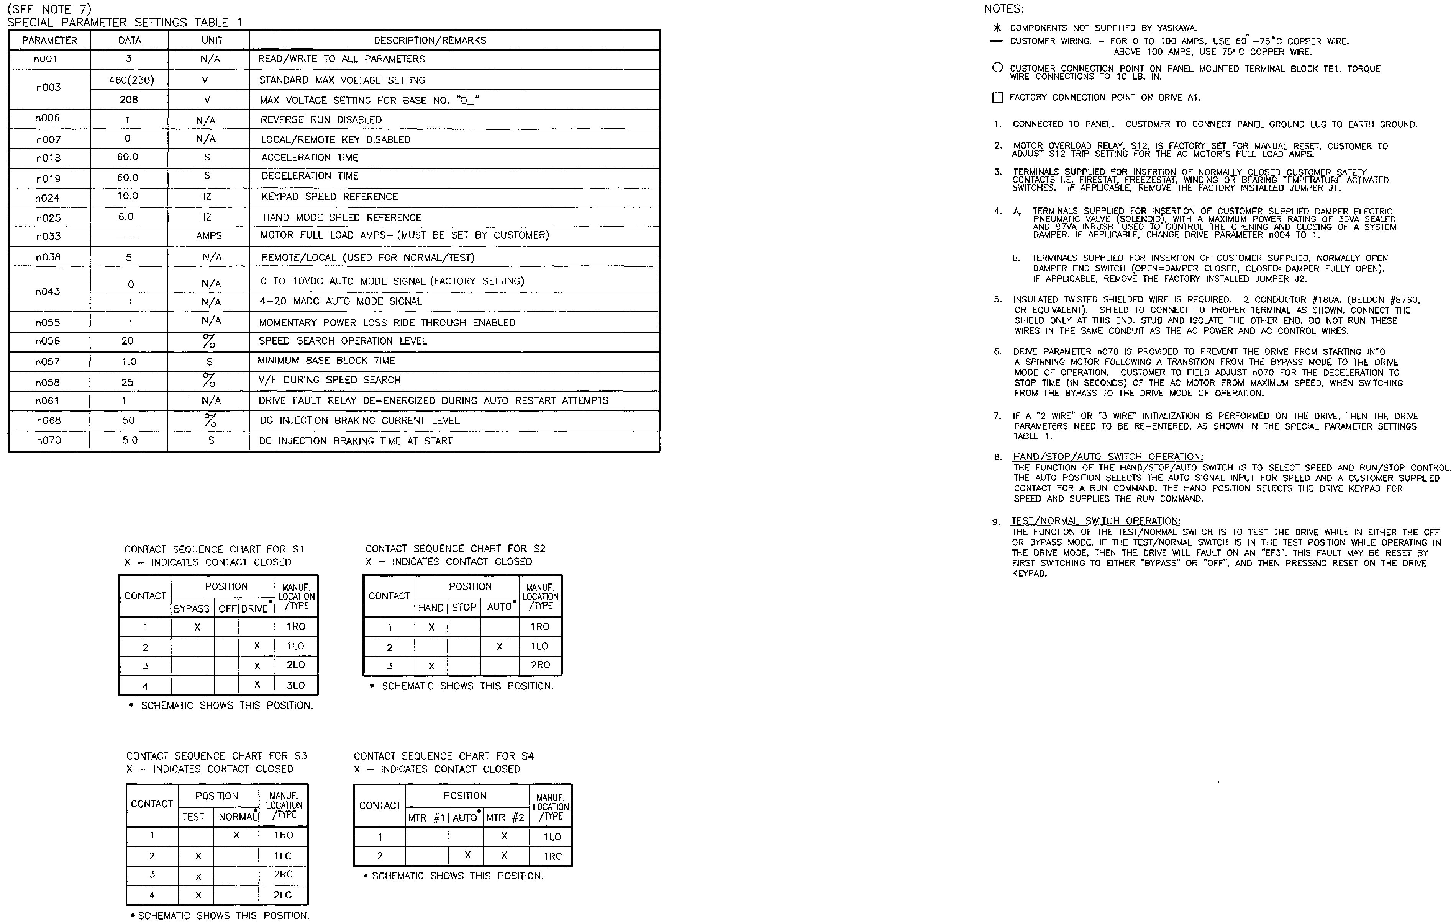

Document: C21-2MTR-OR
Sheet 2 of 2

;
Contractor
Address
Job Name:
Contractor:

;
Contractor
Address

