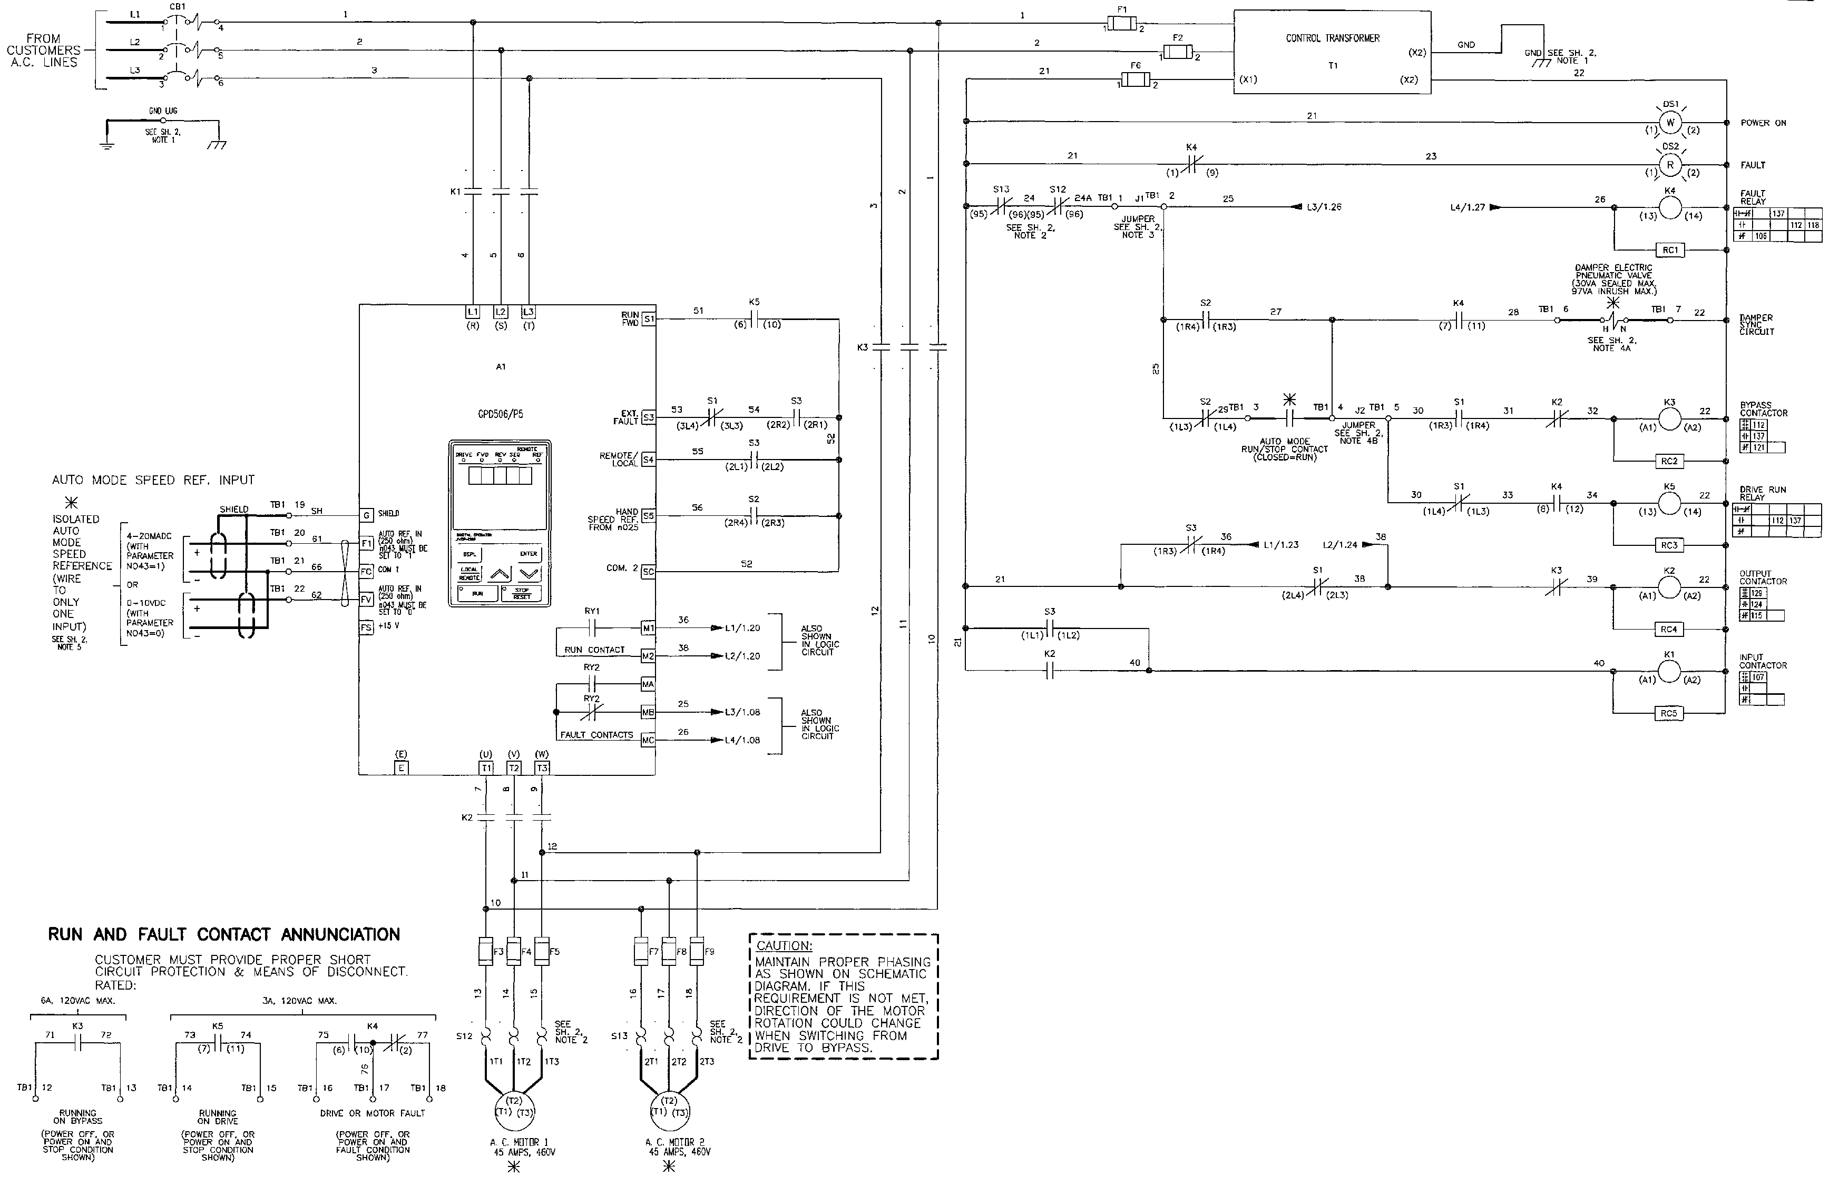

Document: C21-2MTR-AND
Sheet 1 of 2

;
Contractor
Address
Job Name:
Contractor:

;
Contractor
Address

